TABLE CS1

Part 1

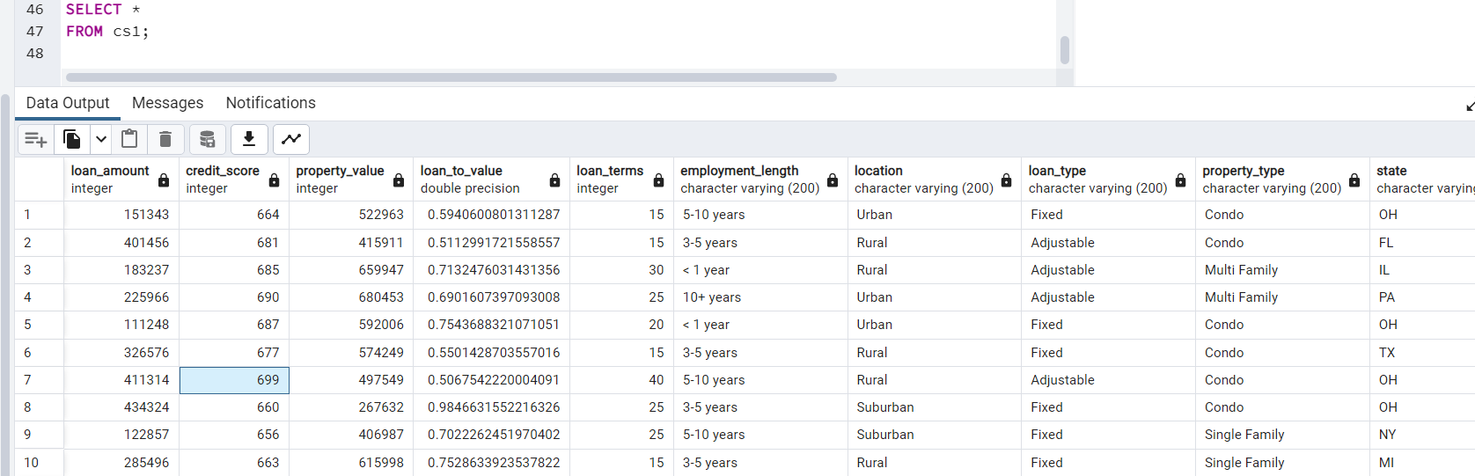

Part 2

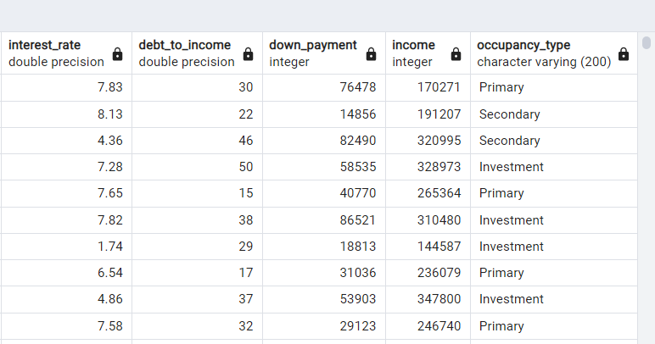

TABLE CS2

Part 1

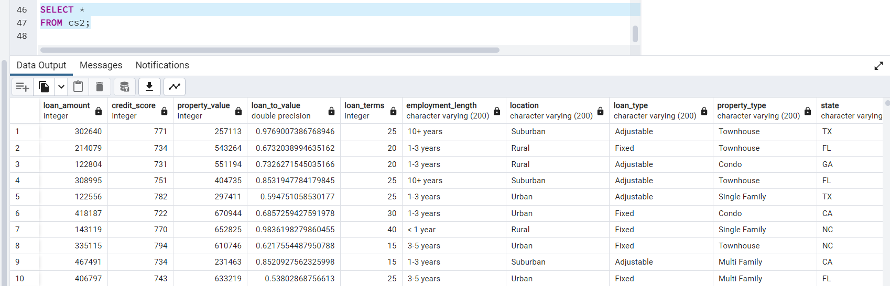

Part 2

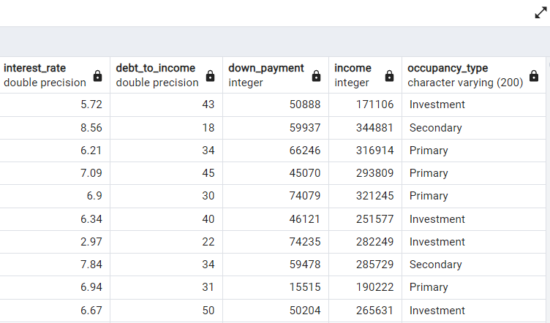

TABLE CS3

Part 1

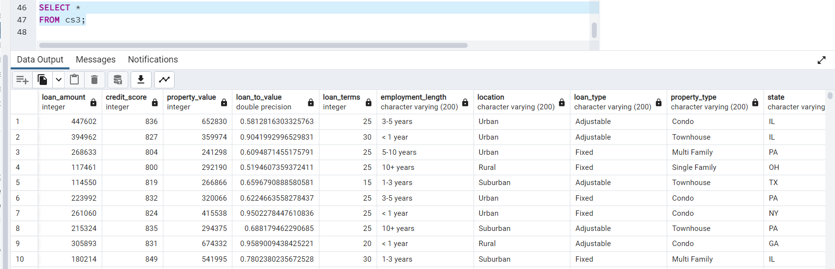

Part 2

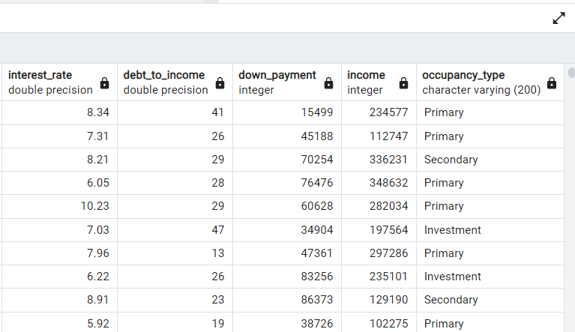

DEBT TO INCOME SUMMARY



DOWN PAYMENT SUMMARY



INCOME SUMMARY



INTEREST RATE SUMMARY

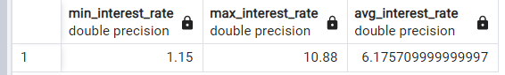

LOAN TERMS SUMMARY

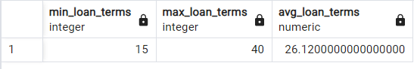

LOAN TO VALUE SUMMARY

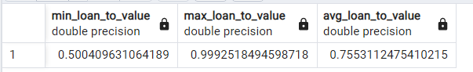

CREDIT SCORE SUMMARY

